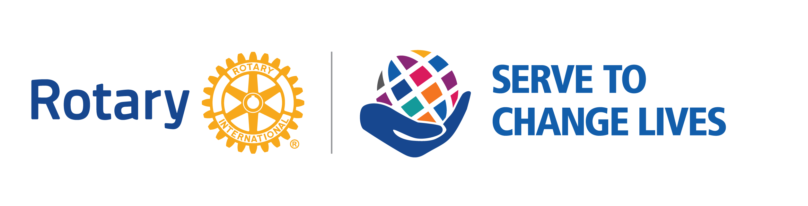
2021-2022 ROTARY QUICK GUIDE

Rotary’s Motto – Service Above Self

Rotary’s 4-way test of the things we think, say and do –
First, Is it the truth?
Second, Is it fair to all concerned?
Third, Will it build goodwill and better friendships?
Fourth, Will it be beneficial to all concerned?

Rotary International Theme for 2021-2022 – Serve To Change Lives

RI President 2021-2022: Shekhar Mehta; Rotary Club of Calcutta-Mahanagar, West Bengal, India

Rotary’s Core Values – Service, Fellowship, Diversity, Integrity, Leadership

Rotary’s Vision: Together, we see a world where people unite and take action to create lasting change — across the globe, in our communities, and in ourselves.

Rotary’s Strategic Priorities and objectives: Increase our impact, expand our reach, enhance participant engagement, and increase our ability to adapt.

Rotary’s Mission: The mission of Rotary International is to provide service to others, promote integrity, and advance world understanding, goodwill, and peace through its fellowship of business, professional, and community leaders.

What is Rotary: An organization of business and professional leaders united to do community service. Through Rotary clubs, people from all continents and cultures come together to exchange ideas, and form friendships and professional connections while making a difference in their backyards and around the world. Rotarians are People of Action!

Seven Areas of Focus:
